Project: Project 2 – Phone Number Parser with HTML output

Name: Michael Fox

Date: 160928

Description:

The project will read in a text file then use regular expressions to parse out the phone numbers that are in more than one format. The numbers are read into a Phone Number class then stored in a Phone Number List class. The numbers are then written using code from project 1 to an HTML file that has the same name as the input file from the command line but with the html extension.

I created a couple of batch files to clean and build the project from the command prompt. The build would embed the manifest and produce the jar file along with running it to create the html file. I used the IntelliJ editor and did some debugging with it. The main class is called Project02Fox.

In this project I started experimenting with JavaDoc as well. The comments can be automatically generated through IntelliJ by hitting Control-I then selecting to build JavaDoc through its tools.

Here is the output as seen using Internet Explorer:

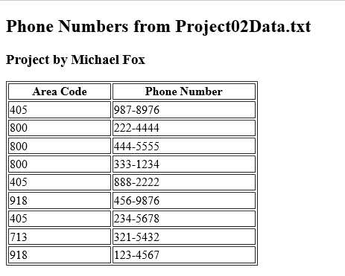

Here is the version information of the compiler:

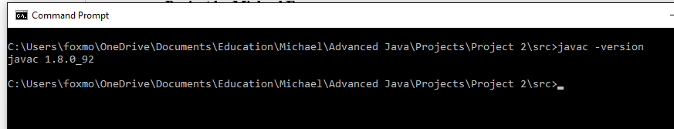

Here is the project being built and ran:

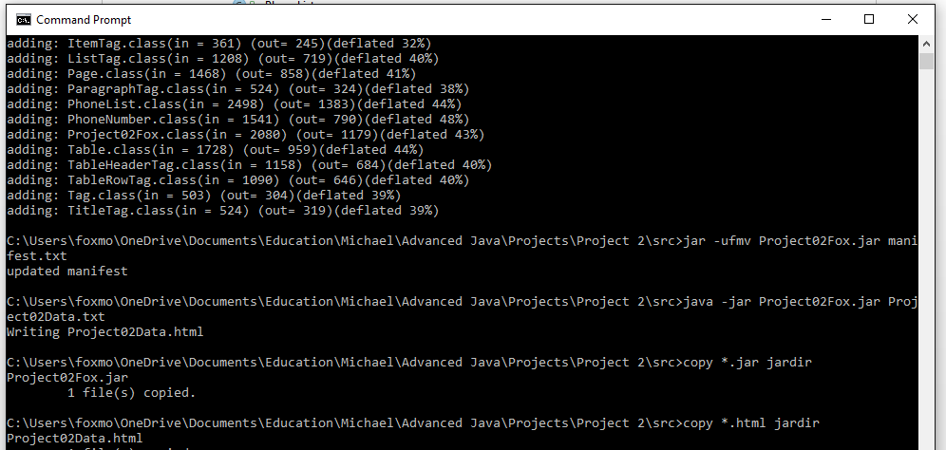

Here is the class layout in IntelliJ:

